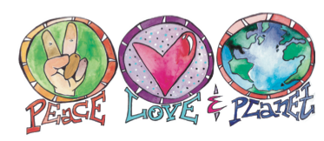
Celebrate recycling the week of Nov. 13th

Hello,

Recycling is the easiest thing we can all do to improve our community, conserve natural resources, and create green jobs. America Recycles Day is a national holiday and falls on Nov. 15th. We will capitalize on this holiday to promote recycling. During the week of Nov. 13th, Green Team (GT) volunteers are helping students to be awesome recyclers by monitoring cafeteria trash stations and collecting data.

Event:
Starting Monday, Nov. 13th, GT volunteers will:
1. Make announcements each day stating one fact.
2. Members will monitor cafeteria recycle/trash bins during the last 10 minutes of lunch period and encourage classmates to recycle. *Optional- Weigh recyclables and trash at the end of lunch to track volumes and record data. Attached is the volunteer sign up. Please excuse students who may run a few minutes late after lunch due to the assessment process.

We will email an activity worksheet at the end of the week for students to calculate recycle volumes based on real data collected during the waste assessment. This optional activity will reinforce the positive impacts of recycling and can be assigned as extra homework.

3. Make a poster graphing results and hang in cafeteria. Make announcements during lunch to share results.

Impact:
We believe that practicing recycling will help make conserving resources and protecting nature second nature at school and at home! Fresh air, clean water and nature preservation benefits everyone!

Thank you for your support!

