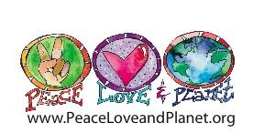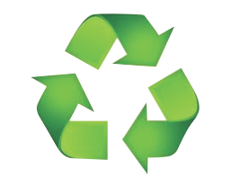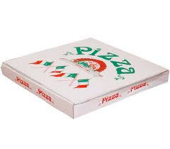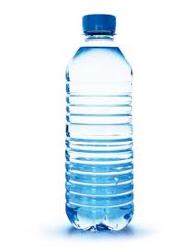

MIXED MATERIALS

RECYCLING

**Plastic bottles & Aluminum Milk & Juice Cardboard**

**containers cartons**

Please EMPTY -no food or liquids