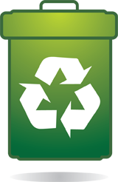
Recycle Monitor Schedule
Week of November 16th
Thank you for VOLUNTEERING to monitor stations and measure trash/recycling! This week we are celebrating recycling by challenging peers to be awesome recyclers! Our goal is to kindly encourage your classmates to recycle and answer questions.
 | Monday  11/16  VOLUNTEERS | Tuesday  11/17  VOLUNTEERS | Wednesday  11/16  VOLUNTEERS | Thursday  11/17  VOLUNTEERS | Friday  11/18  VOLUNTEERS
1stLunch
1.
2.
3.
4.
2nd lunch
1.
2.
3.
4.
3rd Lunch
1.
2.
3.
4.
4th Lunch
1.
2.
3.
4.
INSTRUCTIONS: 1. Grab a pair of disposable rubber gloves (by noon aide station) and “Eco Hero” neck tag. 2. Stand with a partner by the recycle / trash bins during the last 10 minutes of the lunch period. 3. Using scale (on stage) weigh trash and recycling bags and record data on clipboard.

